Welcome to the Laguna Vista,

Historic Restaurant & Saloon

The Best Happy Hour
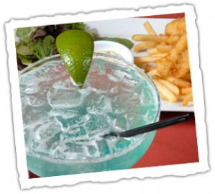
A great place to meet friends or make new ones. We have an extensive wine and beer list and outstanding cocktails. Something for everyone and every occasion.

Join us for Happy Hour!
Monday through Sunday
from 4:00 pm - 6:00pm

Ask about our nightly drink specials.

Enjoy Calamity Jane’s delicious appetizers or order something off the full Calamity Jane’s menu.

We are available for your private functions.

Enjoy selected wines by the
glass or bottle for half price with dinner
Sundays through Wednesdays

Join us in the Courtyard for an alfresco lunch

Historic Tours from 11:00am – 4:00pm
Bring this flyer and your room key to our Saloon for one free cocktail

